2018 Annual Report
Our mission is to equip individuals with the gospel and the
resources necessary for abundant living.

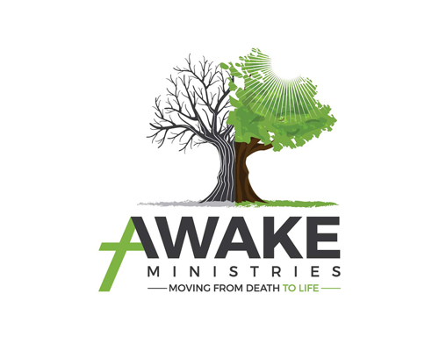

Year in Review
- Awake Ministries provided weekly assistance to an average of 2,000 people in need through our recovery programs and community food distribution.
- Awake Ministries provided long term residential recovery to 59 men and 21 women.
- Awake Ministries provided recovery assistance to 56 individuals through the Intensive Outpatient Program (IOP).
- Awake Ministries hosted 260 recovery support group meetings on-site with an average weekly attendance of 51.
- Awake Ministries placed 32 clients into full-time employment through program partners.
- Awake Ministries distributed food assistance to an average of 1,500 people through the Serenity Center food bank.
- Awake Ministries supplemented food scarcity to 300 identified school children through the backpack program.
- Awake Ministries provided over 100 volunteer opportunities each week.
Awake Ministries operated at or near capacity in both our men’s and women’s residential recovery facilities. To reach more people, we began an Intensive Outpatient Program that enables us to make our resources available without the need of housing.
Our food pantry continues to do amazing things by declaring war on food insecurities. Through this program we can meet the needs of our community’s veterans, families, and school children. To better understand where food insecurity has its greatest impact, we have recently implemented new technology that allows us to capture valuable in formation that will assist in the battle against hunger.
Awake Ministries has launched a new and improved website where the community can learn more about

the mission and vision of our organization. The website includes links to all Awake’s social media
outlets, which are being utilized as tools for enhanced volunteer and community engagement.
Awake hosted its first annual Praise in the Park event in July and its EOY fundraiser at the historic Wakefield Scearce Gallery, which added revenue of nearly $50,000.

Board of Directors
Lee Murphy- Chairman
Jonathan Hale- Vice Chairman
Kevin Comp- Secretary
Marcy Mudd- Treasurer
Jim Smith
Kris Hayden
Joanna Lynch

Financial Report
January 1,2018 – December 31, 2018
Revenue and support
Business $81,682
Church $101,154
Grant $109,347
Individual $75,650
Program Fees $10,100
Total Revenue $377,933
Expenses
Administrative $210,085
Fundraising $9,882
Total: $219,967

Social Services $88,805
Service Management $85,000
Total Program Expense $173,805

Total Expense $393,772
Change in Assets ($15,839)

Total Assets $745,968
Total Liability -$294,002
Total Equity $451,966

